Diffs for divs

Start off with the old gearbox, undo the bolts that hold the speedo drive on:
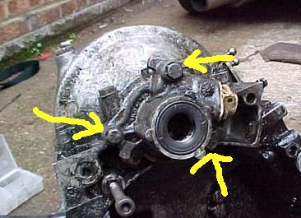

After the speedo drive is removed, undo the 8 bolts that hold on the diff housing (these 4, and the same ones on the other side):
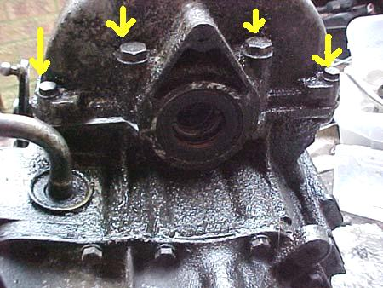
Make sure u have the gearbox this way up when u undo these bolts, otherwise the diff might fall out and damage the crownwheel/your feet.
After you’ve undone all 8 bolts, you should be able to remove the diff housing, which looks like this:
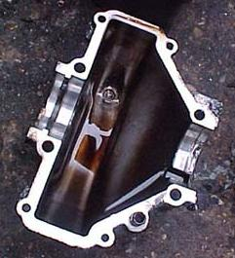

You might have to give it a tap with a hammer or waggle it a bit as its got a dowel that holds it in place and will probably be glued down with sealant.

This should leave you with a gearbox that looks like this:
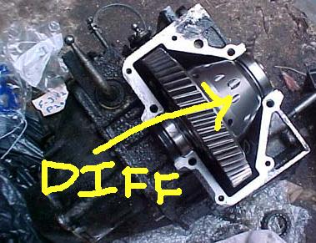

Lift out the diff and put it on some rags or summit soft to protect it.

Give the diff bearings a turn to check theyre not shagged (they will lift out with the diff):
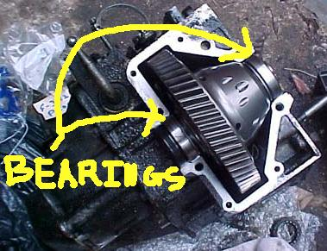

You should now have something that looks like this:
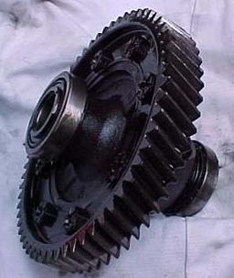

Now do the same for the new mi16 box, don’t worry about confusing the diffs when you have them out, its obvious which is which (the ATB is big shiney and heavy).

Because the final drive ratio is different between the mi16 and 1.9 boxes, the crownwheel on the diff (the ring with all the teeth) has a different number of teeth in each box, so you have to swap the crown wheel from the diff you took out of the mi16 box to the LSD. This is what a crown wheel looks like:
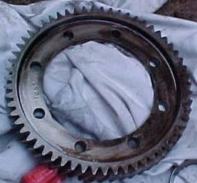
Grab a diff and put it in a vice with some wood between the jaws and the diff to protect it.

Undo the 8 bolts that hold the crownwheel to the diff (they will be tight but not crazy) and take the diff out of the vice, you should be able to pull the crownwheel off the diff…if not tap it gently with a hammer. Bolts:
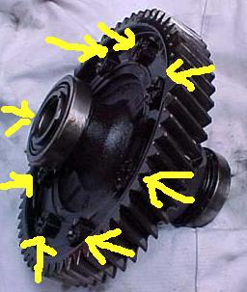

Do the same for the other diff DO NOT CONFUSE THE CROWNWHEELS.

You now need to bolt the crown wheel from the mi16 box onto the LSD.

Get some kitchen roll and stuff it through the holes where the crownwheel bolts onto the diff, you need to get any oil out of the holes.

Now get a bunch of the bolts and wash them in warm soapy water and dry them off, again you want to get rid of any oil.

Put the crownwheel on the diff and wobble it until its in place, it *should* be obvious which way it goes on, thou pay attention when taking them off.

Put some decent threadlock on each bolt and put them into the holes, do them all up fairly tight, then go round torqueing them up (you will need to put the dif back in the vice to do them up tight enough).

Like Haynes says, refitting is the reverse of removal ;)

Put the bearings back on the ends of the diff and put it back in the box. It should mesh in nicely with the cog in the gearbox and turn reasonably easily if you try it.

Run a bead of instant gasket round the edge of the housing (remember the diff is going to be floating in oil so the housing needs to be sealed on). Be very careful not to dribble the sealant into the housing, you don’t want this stuff inside your LSD! Sealant round the housing:
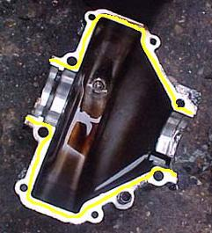

Trial fit the housing onto the gearbox, then lift it off again and remove any sealant that’s squidged inside. Put it back on again and put in the 8 bolts (might be a torque wrench setting…I just did em up FT).

Next put on the speedo drive, make sure u put the white plastic thing onto the end of the diff and then drop the housing over it, do up the 3 bolts. This bit is easy to get wrong, I did the first time then had to take the speedo drive off with the box on the car when the driveshaft wouldn’t go in. Cant remember what the problem was, but trial fit a driveshaft into it to check you’ve got it right!

Finally, put driveshaft oil seals in.

☺

